Comprehensive Reporting Lab Report

1. Lab Overview
This lab focused on creating a professional PTES-compliant red team report using Google Docs and Draw.io. Activities included documenting findings, creating attack path visualizations, assigning CVSS scores, and preparing an executive-level summary.

2. Tools Used
• Google Docs
• Draw.io

3. Executive Summary
A simulated red team engagement was conducted to evaluate the organization’s security posture against realistic adversarial techniques. The assessment identified weaknesses in phishing resistance, credential management, endpoint visibility, and privilege escalation controls.

4. Executive Brief
The security assessment simulated a real-world cyberattack to evaluate the organization’s ability to detect and respond to modern threats. The exercise identified weaknesses involving phishing, weak credential protection, and insufficient monitoring controls. Implementing the recommended security improvements will significantly strengthen the organization’s cyber resilience.

5. Findings Table

Finding ID | TTP | CVSS Score | Severity | Remediation
FID001 | Phishing (T1566) | 7.5 | High | Enforce MFA
FID002 | Credential Dumping (T1003) | 8.1 | High | Enable EDR Monitoring
FID003 | Scheduled Task Persistence (T1053) | 6.8 | Medium | Audit Scheduled Tasks
FID004 | Remote Service Abuse (T1021) | 7.2 | High | Implement Segmentation
FID005 | PowerShell Execution (T1059.001) | 6.5 | Medium | Enable Script Logging

6. Detailed Findings

FID001 — Phishing Attack
Description: Users were susceptible to phishing-based credential theft.
Recommendation: Enforce MFA and conduct phishing awareness training.

FID002 — Credential Dumping
Description: Credential dumping techniques extracted password hashes.
Recommendation: Enable LSASS protection and deploy EDR solutions.

FID003 — Scheduled Task Persistence
Description: Persistence was achieved using scheduled tasks.
Recommendation: Audit scheduled tasks and restrict permissions.

FID004 — Remote Service Abuse
Description: Remote protocols were abused for lateral movement.
Recommendation: Restrict remote administration and segment networks.

FID005 — PowerShell Execution
Description: PowerShell was used for post-exploitation activities.
Recommendation: Enable PowerShell logging and restrict scripts.

7. Attack Path Diagram
The following diagram illustrates the simulated attack flow from initial phishing to critical system access.

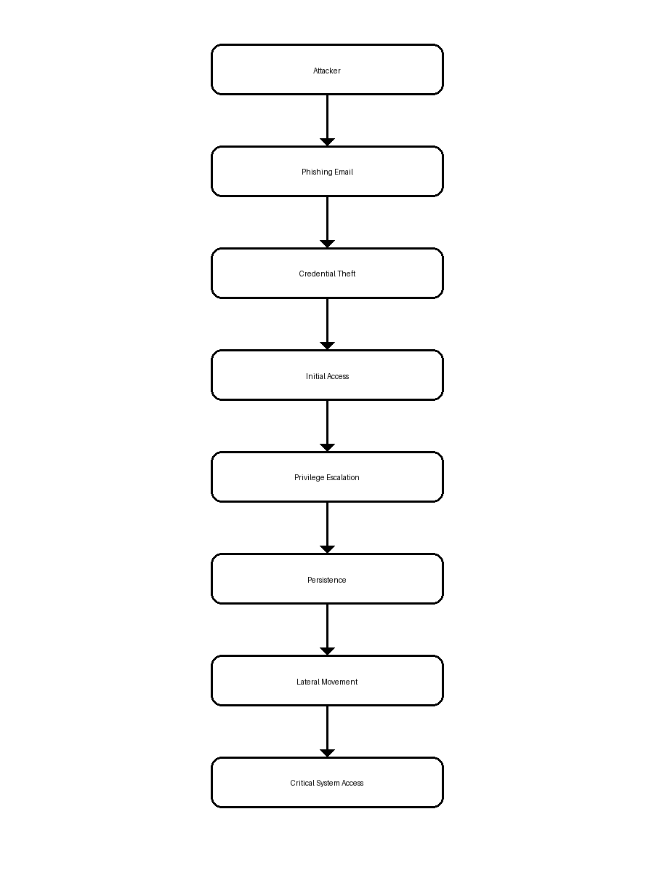

8. Recommendations Summary
• Enforce multi-factor authentication
• Conduct phishing awareness training
• Enable centralized logging and monitoring
• Restrict remote administration protocols
• Deploy endpoint detection and response solutions

9. Conclusion
The Comprehensive Reporting Lab demonstrated the importance of structured red team documentation and executive communication. The PTES-aligned report effectively communicated technical findings, risks, and remediation strategies.

